# Homework: Algorithm Complexity and Linear Data Structures

This document defines the **homework assignments** for the ["Data Structures" course @ Software University](https://softuni.bg/trainings/1147/Data-Structures-June-2015).  
You can check your solutions here: <https://judge.softuni.bg/Contests/Practice/Index/551#0>

## Sum and Average

Write a program that reads from the console a sequence of integer numbers (on a single line, separated by a space). Calculate and print the **sum** and **average** of the elements of the sequence. Keep the sequence in List<int>. Round the average to second digit after the decimal separator.

|  |  |
| --- | --- |
| **Input** | **Output** |
| 4 5 6 | Sum=15; Average=5.00 |
| 1 1 | Sum=2; Average=1.00 |
|  | Sum=0; Average=0.00 |
| 10 | Sum=10; Average=10.00 |
| 2 2 1 | Sum=5; Average=1.67 |

## Sort Words

Write a program that reads from the console a **sequence of words** (strings on a single line, separated by a space). **Sort** them alphabetically. Keep the sequence in List<string>.

|  |  |
| --- | --- |
| **Input** | **Output** |
| wow softuni alpha | alpha softuni wow |
| hi | hi |
| rakiya beer wine vodka whiskey | beer rakiya vodka whiskey wine |

## Longest Subsequence

Write a method that finds the **longest subsequence of equal numbers** in given List<int> and returns the result as new List<int>. If several sequences has the same longest length, return the leftmost of them. Write a program to test whether the method works correctly.

|  |  |
| --- | --- |
| **Input** | **Output** |
| 12 2 7 4 **3 3** 8 | 3 3 |
| **2 2 2** 3 3 3 | 2 2 2 |
| 4 4 **5 5 5** | 5 5 5 |
| **1** 2 3 | 1 |
| **0** | 0 |
| 4 2 3 **4 4** | 4 4 |

## Remove Odd Occurrences

Write a program that **removes** from given sequence all numbers that occur **odd number of times**.

|  |  |  |
| --- | --- | --- |
| **Input** | **Output** | **Comments** |
| 1 **2 3 4** 1 | 1 1 | 2, 3 and 4 occur odd number of times (once). 1 occurs 2 times |
| **1 2** 3 **4 5** 3 **6** 7 **6** 7 **6** | 3 3 7 7 | 1, 2, 4, 5 and 6 occurs odd number of times 🡪 removed |
| 1 2 1 2 1 2 |  | All numbers occur odd number of times 🡪 removed |
| **3** 7 **3 3** 4 **3** 4 **3** 7 | 7 4 4 7 | 3 occurs odd number of times (5) 🡪 removed |
| 1 1 | 1 1 | All numbers occur even number of times 🡪 sequence stays unchanged |

## Count of Occurrences

Write a program that finds in given array of integers **how many times each of them occurs**. The input sequence holds numbers in range [0…1000]. The output should hold all numbers that occur at least once along with their number of occurrences.

|  |  |
| --- | --- |
| **Input** | **Output** |
| 3 4 4 2 3 3 4 3 2 | 2 -> 2 times  3 -> 4 times  4 -> 3 times |
| 1000 | 1000 -> 1 times |
| 0 0 0 | 0 -> 3 times |
| 7 6 5 5 6 | 5 -> 2 times  6 -> 2 times  7 -> 1 times |

## Implement the Data Structure ReversedList<T>

Implement a data structure ReversedList<T> that holds a sequence of elements of generic type T. It should hold a **sequence of items in reversed order**. The structure should have some **capacity** that **grows twice** when it is filled, **always starting at 2**. The reversed list should support the following operations:

* Add(T item) 🡪 adds an element to the sequence (grow twice the underlying array to extend its capacity in case the capacity is full)
* Count 🡪 returns the number of elements in the structure
* Capacity 🡪 returns the capacity of the underlying array holding the elements of the structure
* this[index] 🡪 the indexer should access the elements by **index** (in range 0 … Count-1) in the reverse order of adding
* RemoveAt(index) 🡪 removes an element by **index** (in range 0 … Count-1) in the reverse order of adding
* IEnumerable<T> 🡪 implement an enumerator to allow iterating over the elements in a foreach loop in a reversed order of their addition

**Note:** For Java, instead of indexer, create methods get(int index) and set(int index, T element). All methods should be with the same names but lowercase.

**Hint:** you can keep the elements in the order of their adding, by access them in reversed order (from end to start).

## * Distance in Labyrinth

We are given a labyrinth of size N x N. Some of its cells are empty (0) and some are full (x). We can move from an empty cell to another empty cell if they share common wall. Given a starting position (*) calculate and fill in the array the minimal distance from this position to any other cell in the array. Use "u" for all unreachable cells.

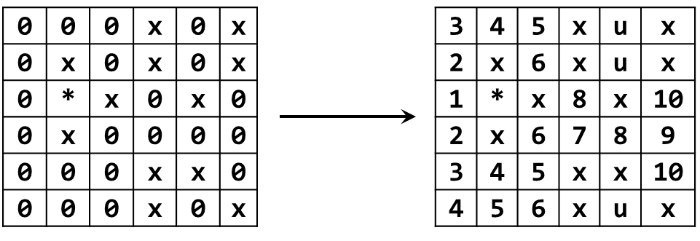

|  |  |
| --- | --- |
| **Input** | **Output** |
| 2  x0  *x | xu  *x |
| 3  000  0*0  000 | 212  1*1  212 |
| 6  000x0x  0x0x0x  0*x0x0  0x0000  000xx0  000x0x | 345xux  2x6xux  1*x8x10  2x6789  345xx10  456xux |